# Workshop 1 -- CSY2085 – Server Administration and Security

STUDENT NAME:

STUDENT NUMBER:

## **This workshop should be completed on your machine if you have at least 32GB spare capacity and 1GB of memory.**

## Task – Acquire license key.

1. Go on the following link and **log in using your student email**
2. <https://azureforeducation.microsoft.com/devtools>

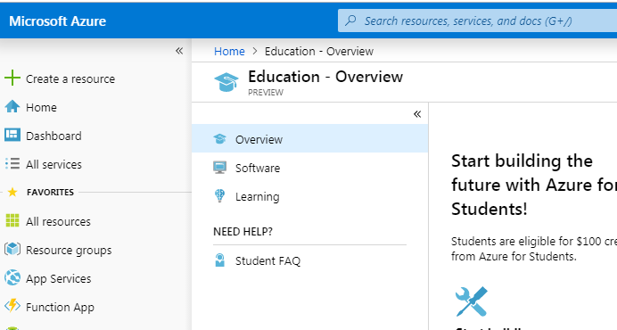

1. Click on software and in the search text box look for “Windows Server 2019”

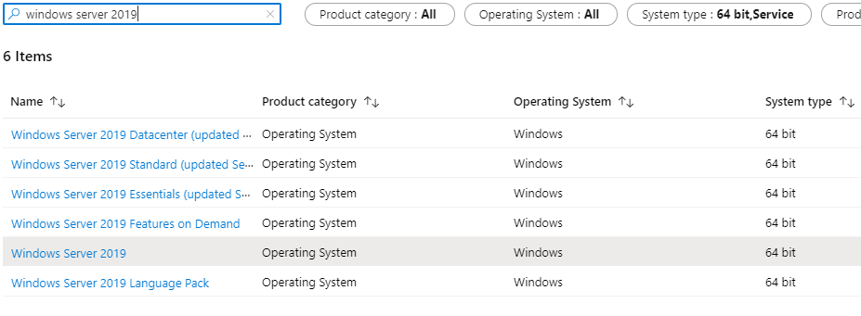

1. Choose the Windows Server 2019 Standard and click on it

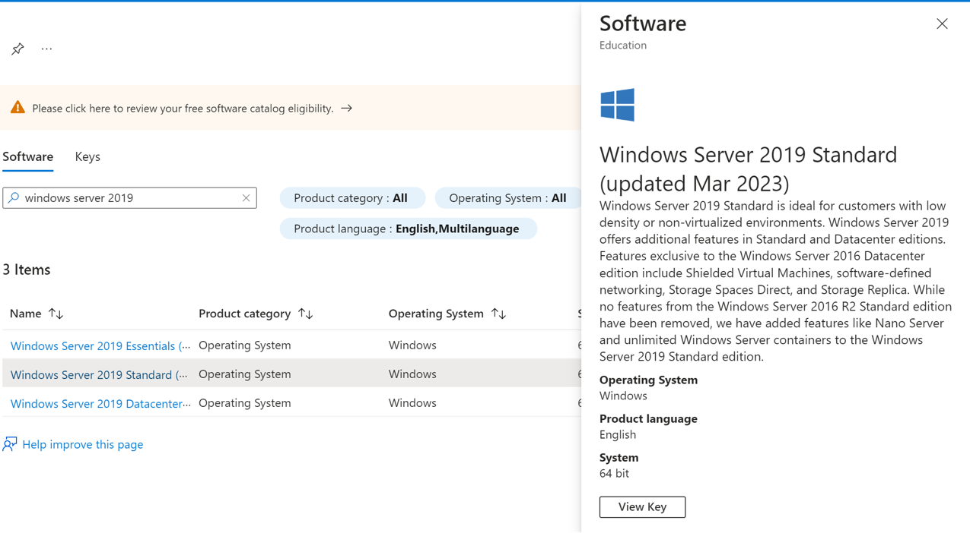

1. Click on the “View Key” to see the licence key and the “Download” to get the .iso installation file. Download the windows Server iso file and save it in known location such as My Documents\Virtual Machines\Windows Server 2019
2. Keep this window open for a while, as you will need the product key in a few minutes.

## Task 1 - Installing and Windows Server 2019 using VMware Player

1. Download and install VMware Workstation Player <https://my.vmware.com/en/web/vmware/downloads/details?downloadGroup=PLAYER-1610&productId=1039&rPId=55792>
2. Locate and start VMware Player. On a Windows PC it will be in the "All Programs" menu under "VMware". Accept any licensing prompts.
3. Click on "Create a New Virtual Machine".
4. Select the option "I will install the operating system later", and click "Next".
5. Select "Microsoft Windows" and then in the dropdown list box, select "Windows Server 2019", and click "Next**.**
6. Change the name of the new virtual machine to "[your student number] Windows 2019". Thus, if your student number is 12345675, then the virtual machine name will be "1234567 Windows 2019". Check the location to make sure that it’s the desired “Virtual Machines” folder (Create this folder if it doesn’t already exist) and click "Next".
7. Change the Maximum disk size to 100 GB.
8. Select the option to "Split virtual disk into multiple file", and click "Next >".
9. Click on "Customise Hardware".
10. Select "Memory" and set the recommended memory to 2 GB.
11. Select "New CD\DVD (IDE/SATA)" and select "Use ISO image file". Click "Browse" and locate the file "**WindowsServer2019.iso**” and click "Open".
12. Click "Close" at the "Hardware" screen, and then click "Finish" at the "New Virtual Machine Wizard" Screen.
13. Select your virtual machine and then click "Play virtual machine".
14. The installation of Windows Server 2019 will start. You might experience an error first asking to press any key to boot from CD/DVD, close down the window and try again. You might have to try a few times.

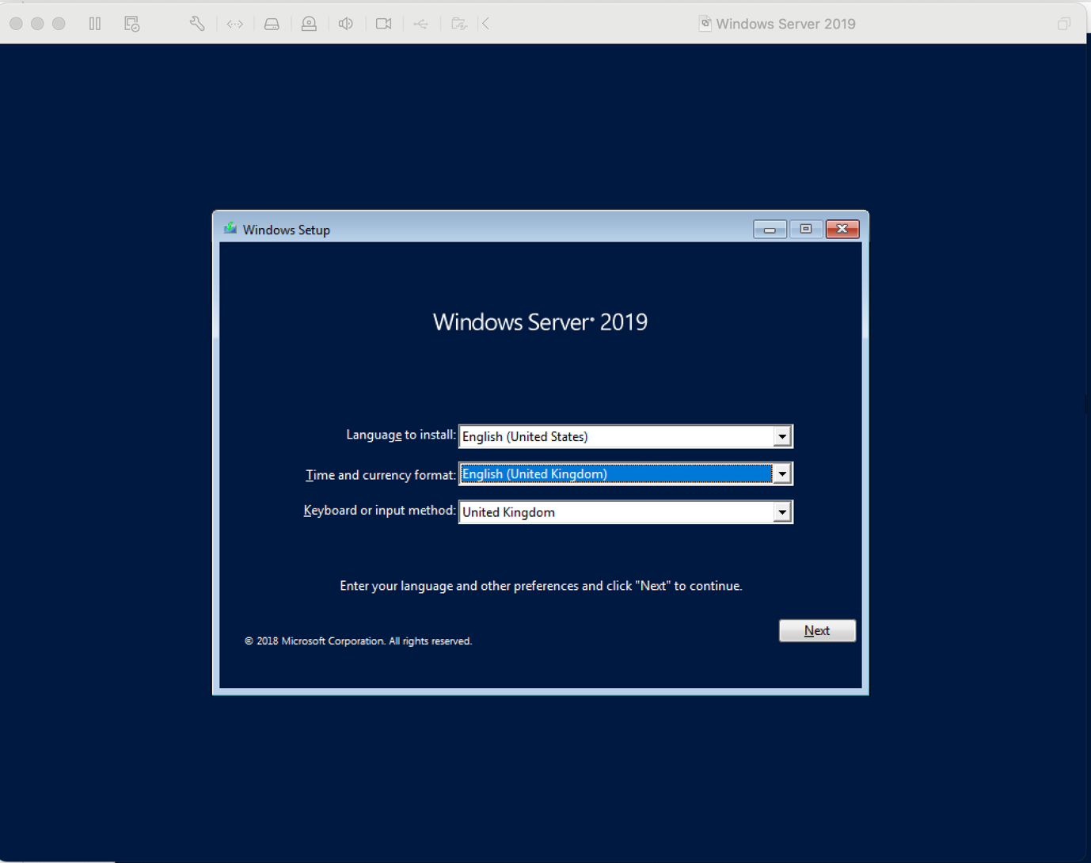

1. Choose the correct “Time and currency format” and “Keyboard or input method” and click “next”.

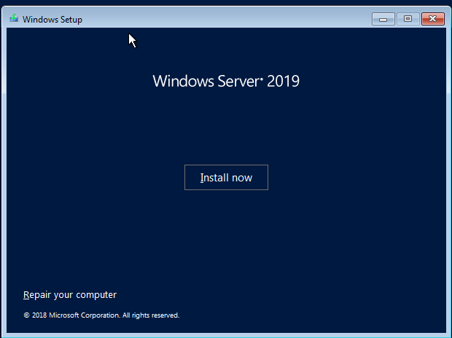

1. Click “Install now”
2. It will ask for your Product Key. Carefully type in the key from the Imagine webstore, then click “Next”.

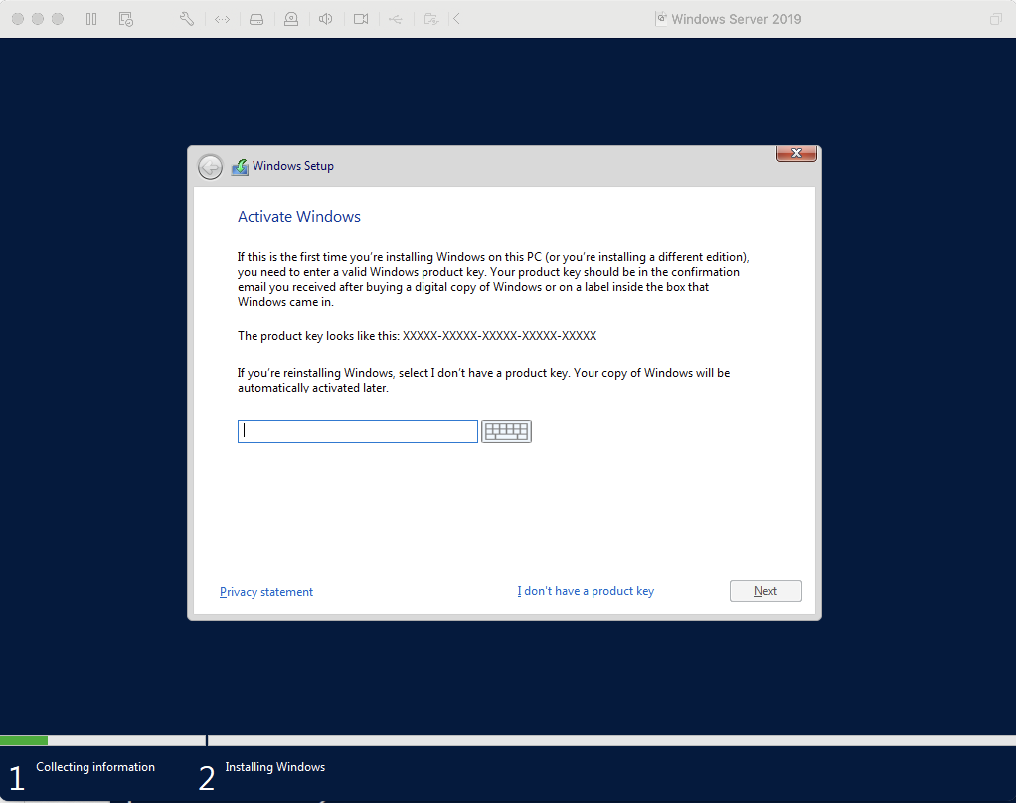

1. Carefully make sure “Windows Server 2019 Standard (Desktop Experience)” is selected, then click “Next”.

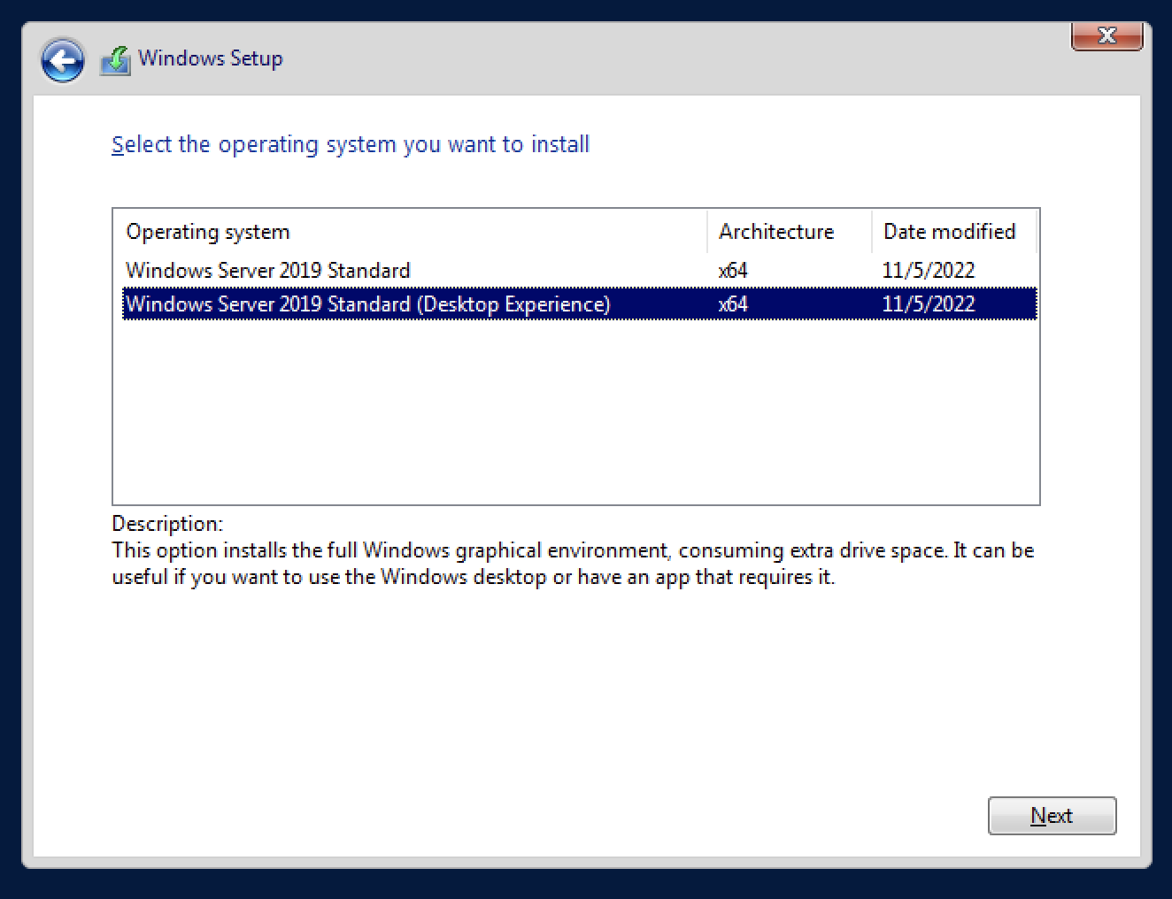

1. Accept the licence agreement, click Next
2. Click “Custom Install Windows only (advanced)”

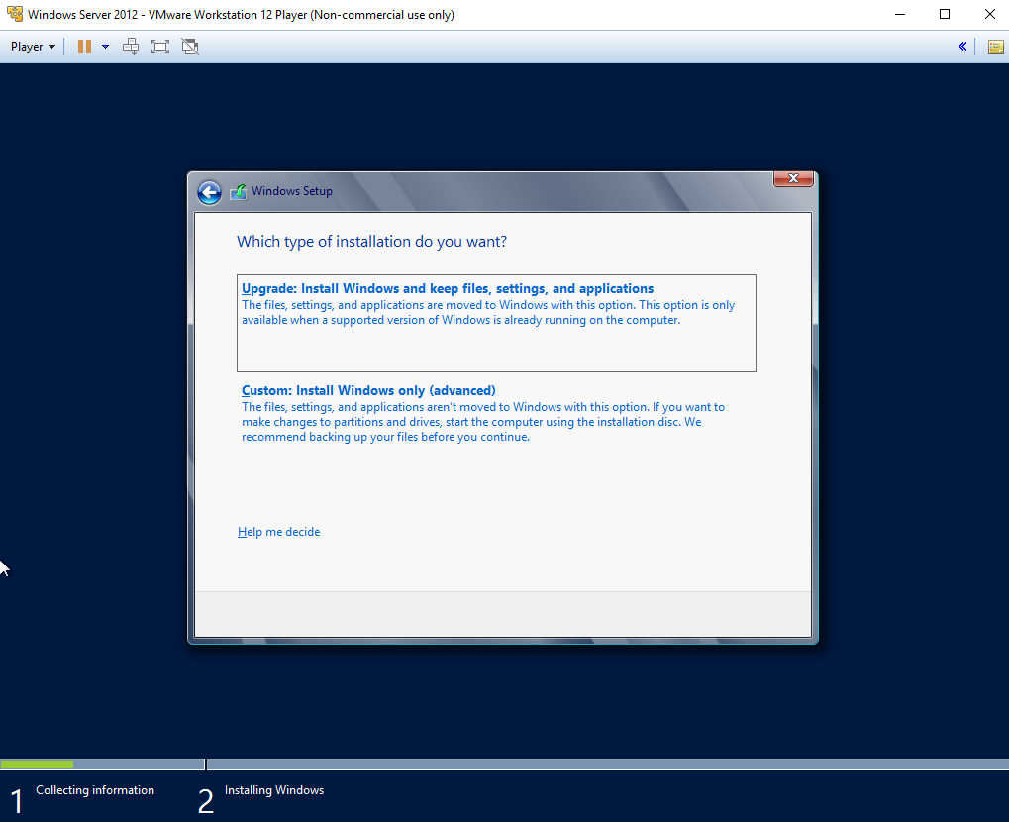

Make sure “Drive 0” is selected, and click Next.

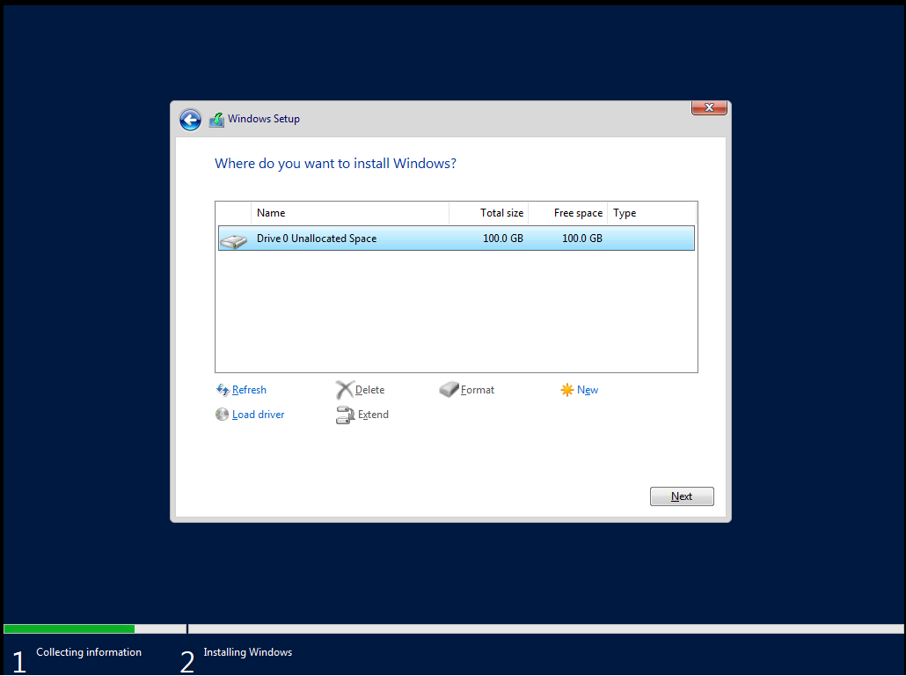

1. Windows should now install.
2. When complete, you’ll be asked to create a password. **MAKE A NOTE, AS YOU’LL NEED IT. DON’T LOSE THIS PASSWORD**

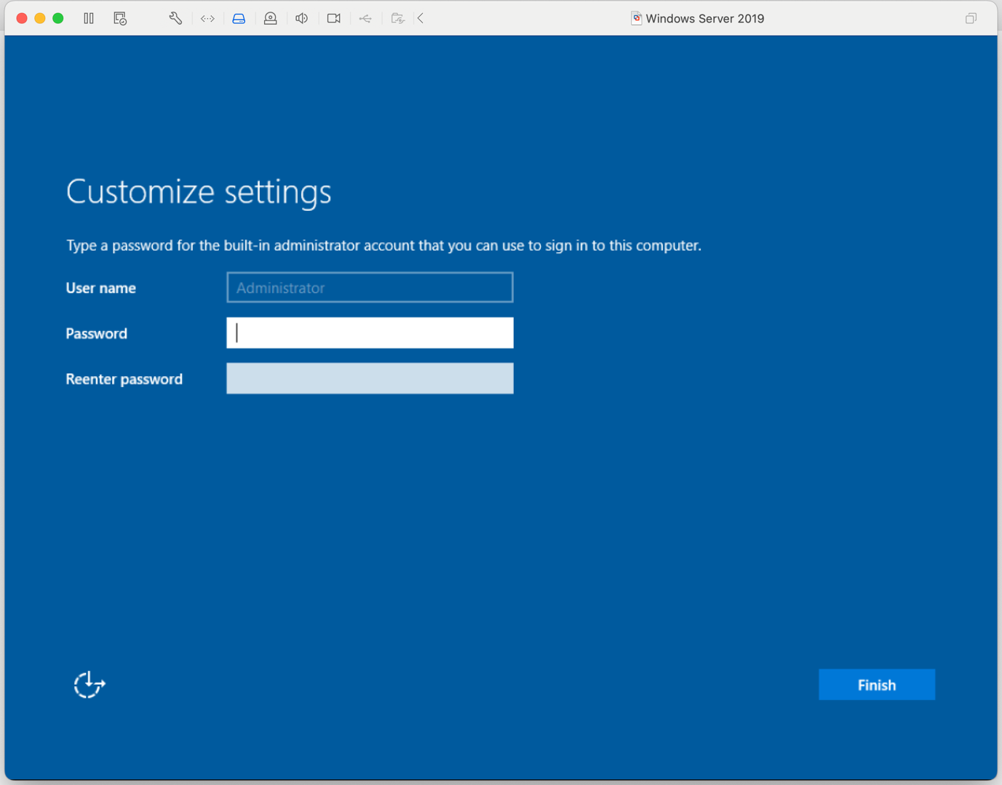

1. Click “Finish”
2. Once the virtual Windows Server 2019 is ready for login on, take a screen shot of it by first selecting the VMware Player windows title and then pressing ALT-PRTSC keys. Paste it below as shown in the example below:

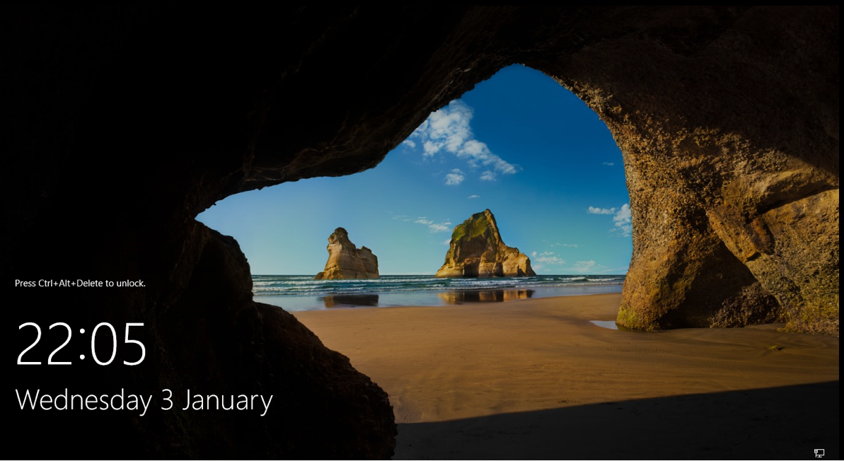

**[Paste your screen shot here]**

## Task 2 – Verifying the Installation

1. On the VMware Player window, click on "Player", then "Send Ctrl+Alt+Del". Log in using the password that you created earlier.

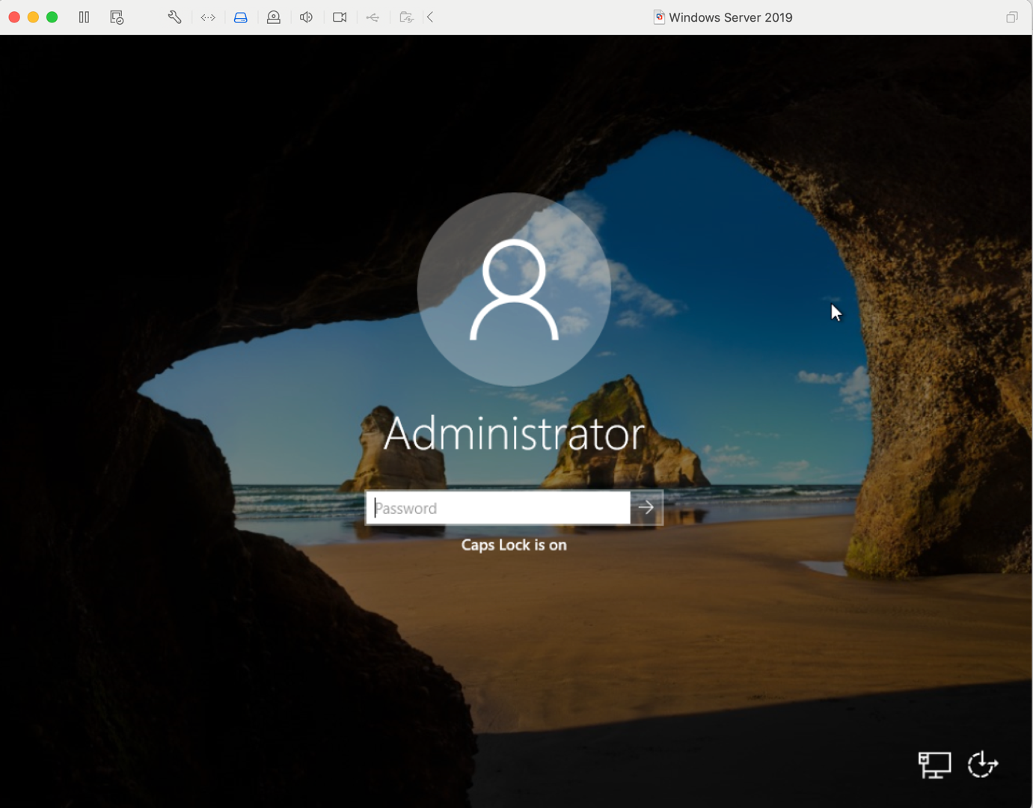

1. You may be asked “Do you want to find PCs, devices and content on this network?”. Click “Yes”.

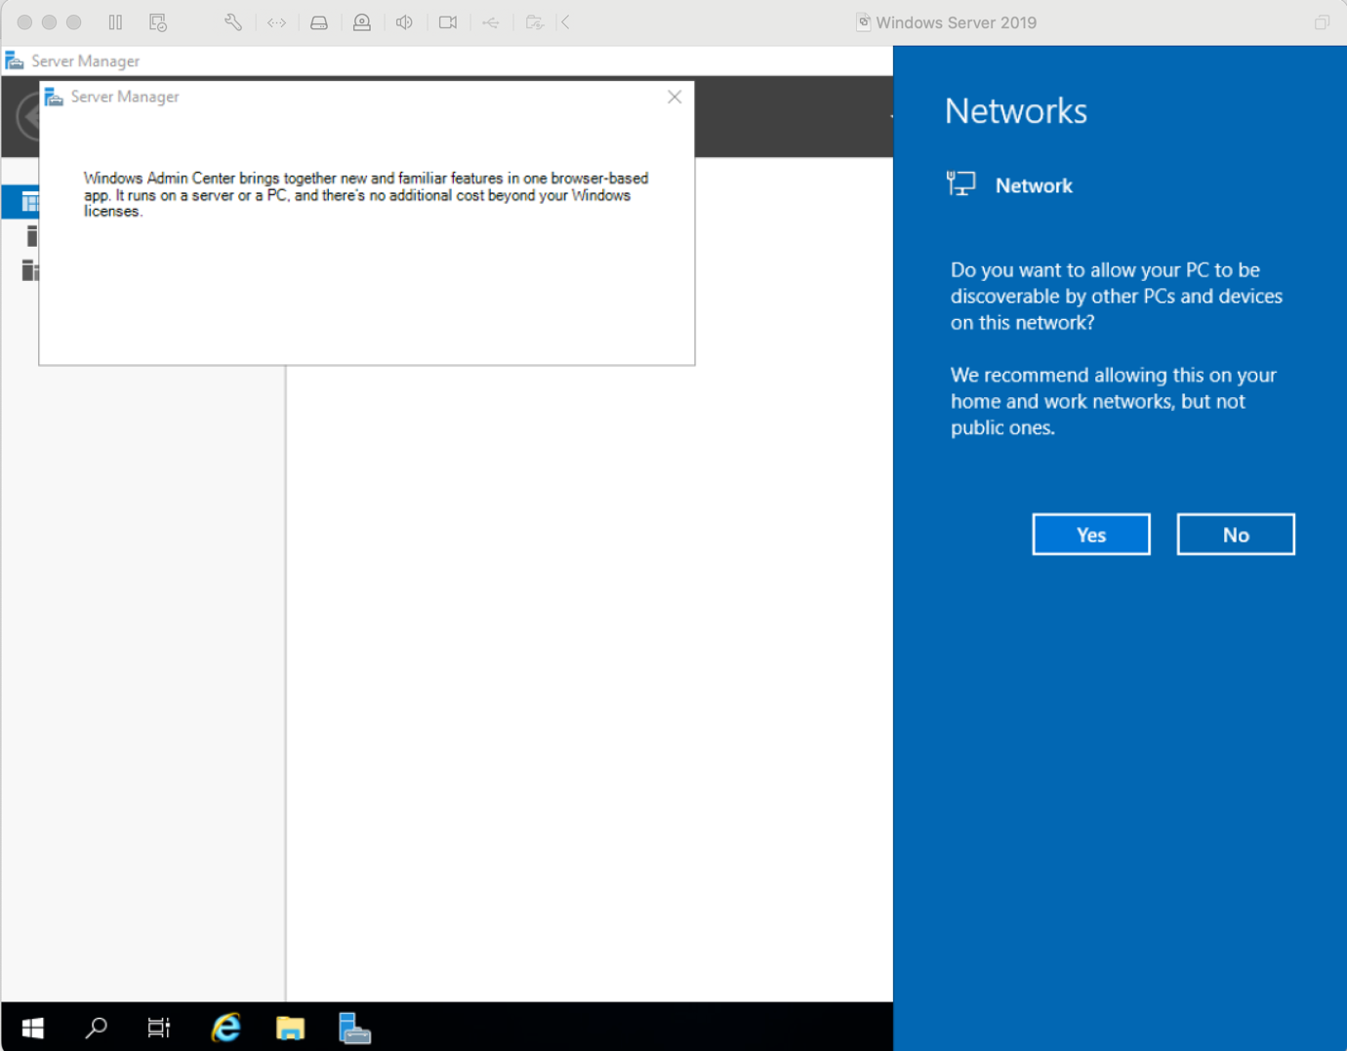

1. Now, to make sure that the Windows Server works well with the VMware software, you need to install the VMware tools.
2. On **WMware Workstation pro**, this can be found on the main menu under “VM”. **On VMware workstation player**, this can be found through Player>Manage>.
3. Install the VMware Tools using "Typical" settings.
4. Restart the Windows Server when prompted. After the Windows Server has restarted, login again.
5. Check that the VMware Tools were successfully installed by maximizing the VMware Player window. The Windows Server desktop should now fill the screen like the example below: 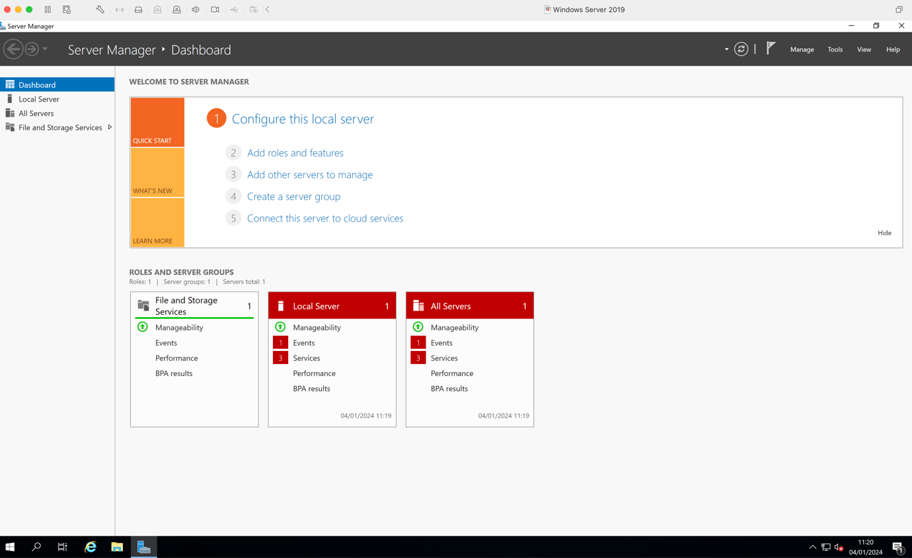
6. Now capture your full screen Windows Server desktop and paste the screenshot into the space below:  
     
   **[Paste your screen shot here]**
7. We are now going to set the Computer Name of this VM.
8. Do a bit of research and find out how to change the name of the server you have created. You should name it using your initials and the student number eg: **AB1234567**
9. Once successful, capture a screen showing the new name and paste it below:

**[Paste your screen shot here]**

1. The server will ask you to restart
2. When restarted, log back in using the password you set for the Administrator.
3. To verify that you have installed the Windows Server system correctly, you will now run the SYSTEMINFO utility. Within the Windows server system, start Windows PowerShell, by opening the start menu:

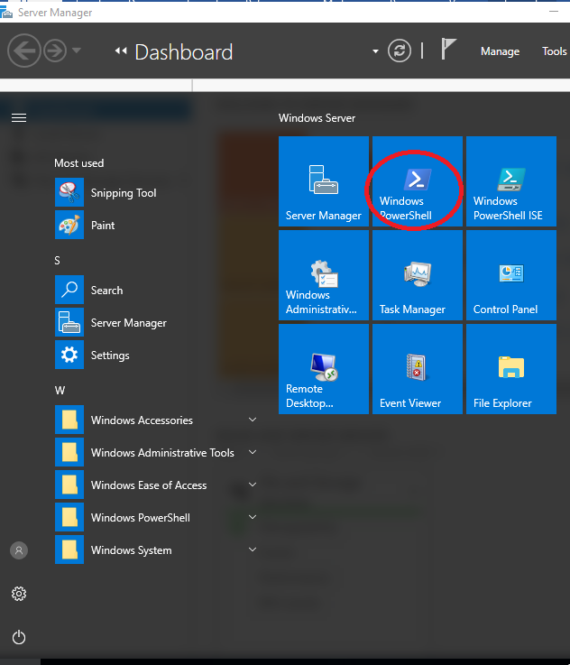

1. Maximize this PowerShell window so that it is as large as it can be. Click within this window window and type the command "**systeminfo**" and press the Return or Enter key.

Capture your own screen paste it into the space below:  
  
**[Paste your screen shot here]**

**What useful information can you deduct from the output of this command?**

**Make sure that the information is legible. Otherwise you will lose marks.**

## Task 3 – Creating User Accounts

1. In Windows Server 2019, right-click on the “Start” button and then click “Computer Management”.

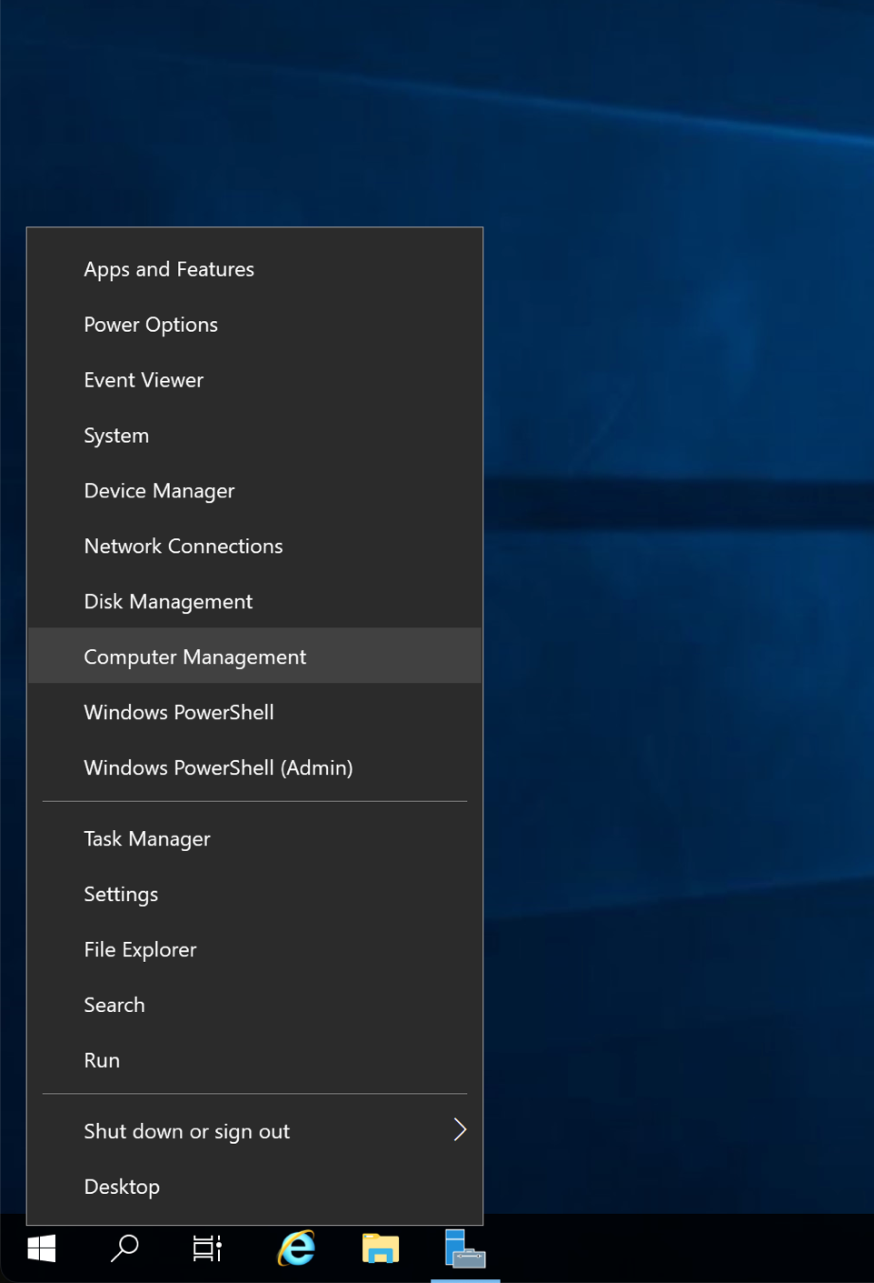

1. Expand the Local Users and Groups folder, until you get the following screen:

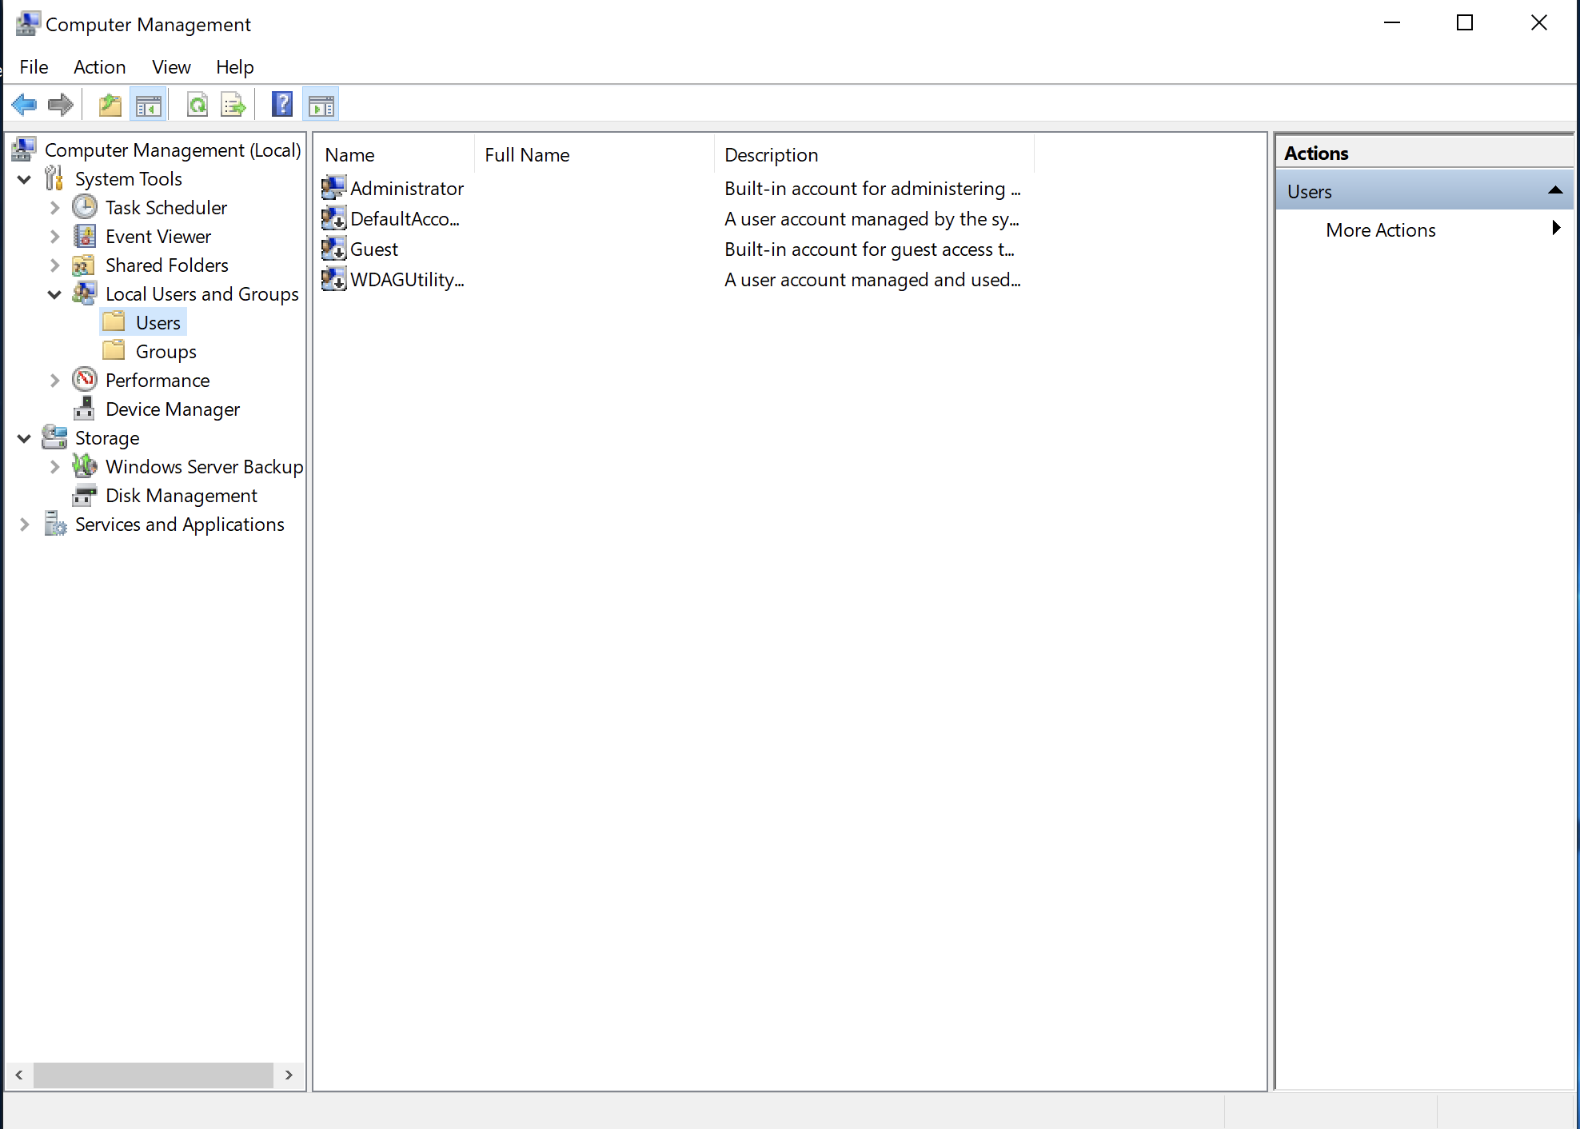

1. Expand More Actions on the right hand side on “Action” and “New User”.
2. Name your new user as your **student ID** such as “**1234567**” and set the password to “**ABCdef123**”.
3. Uncheck(clear) the “User must change password...”, as below:

1. Obviously, use your own name rather than mine!
2. Click “Create” and then “Close”, and your new user should be shown on Computer Management:

1. Capture and paste your equivalent screen below:

**[Paste your screen shot here]**

1. We are now going to make this user an administrator as well so that if anything should happen to the original Administrator account, we have a second chance at logging on and fixing the problem.
2. Do a bit of research of how to do this and paste a screenshot of your result below (the screenshot should show that the new user is now also a member of "Administrators". Capture the screen showing this information and paste it below:

**[Paste your screen shot here]**

## Task 4 – Identify Running Processes

Processes are programs or applications in execution. You will explore the processes using Process Explorer in the Windows Sysinternals Suite. You will also start and observe a new process.

1. Download Windows Sysinternals Suite. Navigate to the following link to download Windows Sysinternals Suite: <https://technet.microsoft.com/en-us/sysinternals/bb842062.aspx>
2. After the download is completed, right+click the zip file, and choose Extract All…, to extract the files from the folder. Choose the default name and destination in the Downloads folder and click Extract.
3. Exit the web browser.
4. Navigate to the SysinternalsSuite folder with all the extracted files.

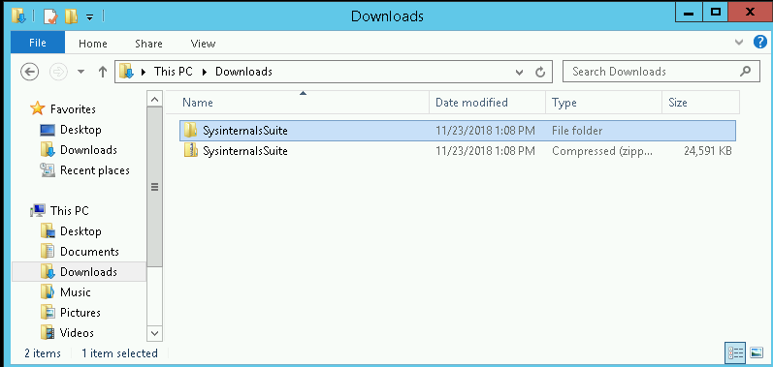

1. Open **Tcpview.exe**. Accept the Process Explorer License Agreement when prompted. Click **Yes** to allow this app to make changes to your device.

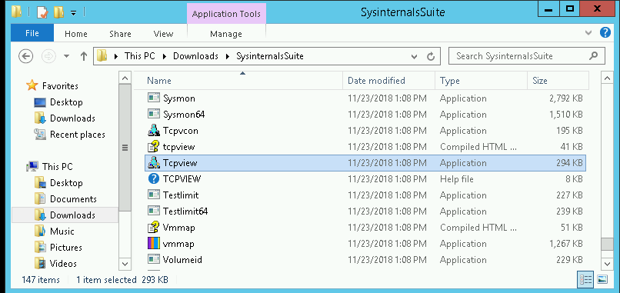

1. Exit the File Explorer and close all the currently running applications.
2. TCPView lists the process that are currently on your Windows Server. At this time, only Windows processes are running.

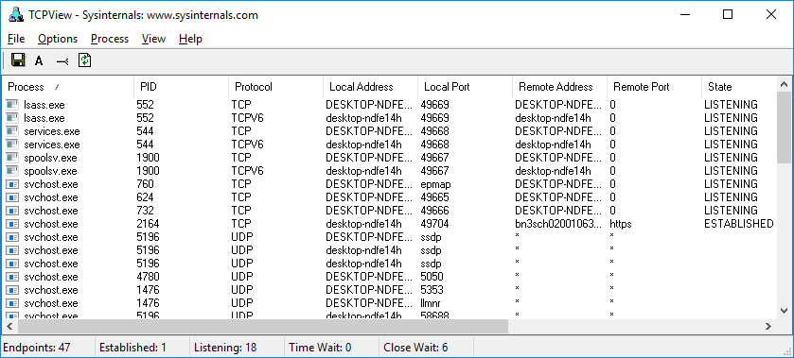

1. Double-click **lsass.exe**. What is lsass.exe? In what folder is it located?

**[Your answer here]**

1. Close the properties window for lsass.exe when done and View the properties for the other running processes.

**Note**: Not all processes can be queried for properties information.

1. Explore a user-started process. Open a web browser, such as Microsoft Edge. What did you observe in the TCPView window?

**[Your answer here]**

**[Paste the corresponding screen shot here]**

1. Close the web browser. What did you observe in the TCPView window?

**[Your answer here]**

1. Reopen the web browser. **Research 3 of the processes listed in TCPView**. Record your findings.

**[Your answer here]**

1. Now shut down your Windows Server by clicking on "Player" then "Send Ctrl + Alt + Del".
2. Click the “Shutdown” button:

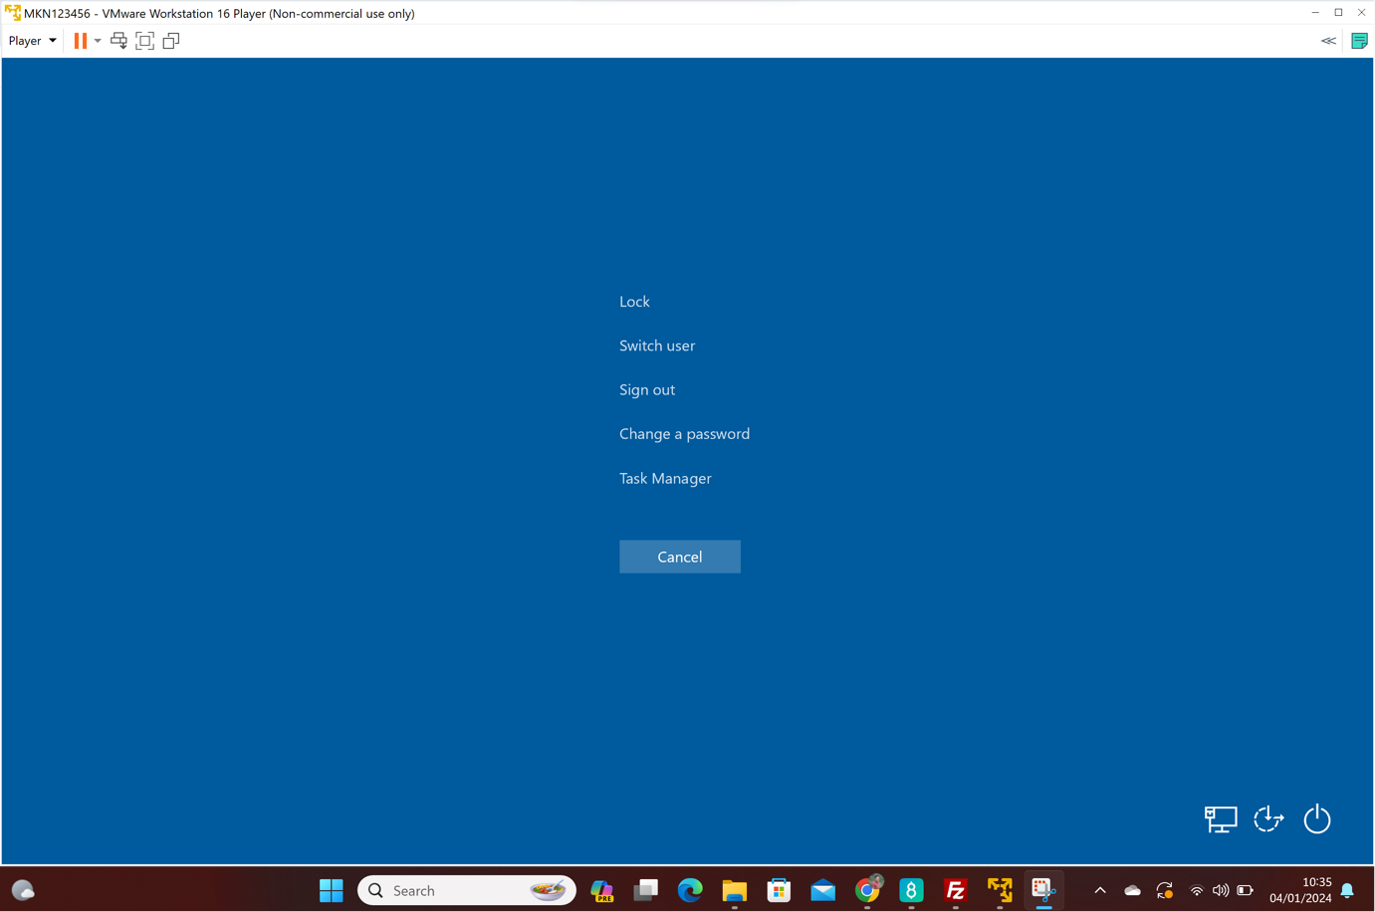

1. Click “Shutdown”, and select “Operating System Reconfiguration”

## Task 5 – Backing up

It is important that you back up your VMware server images regularly, preferably at the end of every workshop. Though not mandatory, it is highly advisable that you also make a copy of your server image onto a removable memory stick or USB drive. Please make sure that no VMware images are running when you are copying them.

1. Using the Windows File Explorer, navigate to "Documents" on your Windows Host PC. Create a new folder inside the Documents folder by right-clicking, and then selecting "New", "Folder":  
   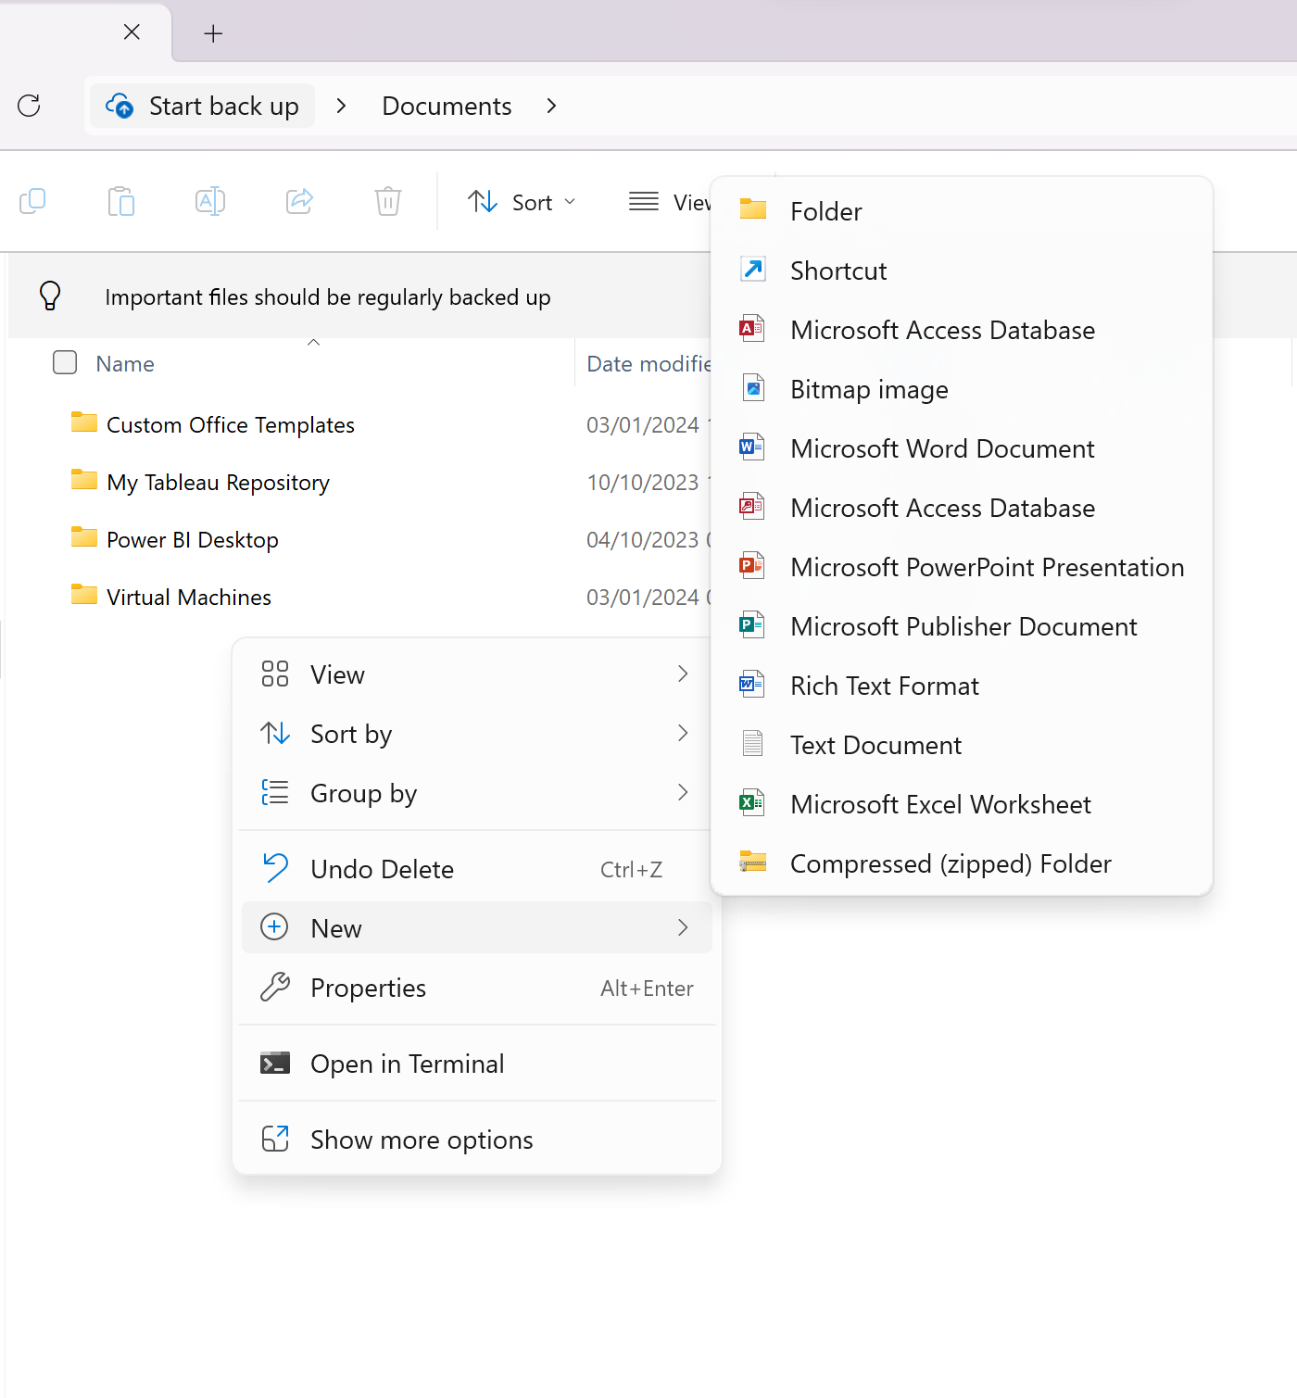
2. Rename the new folder with your student ID eg. "1234567".
3. Then double-click into the "Virtual Machines" and find your server image folder:  
   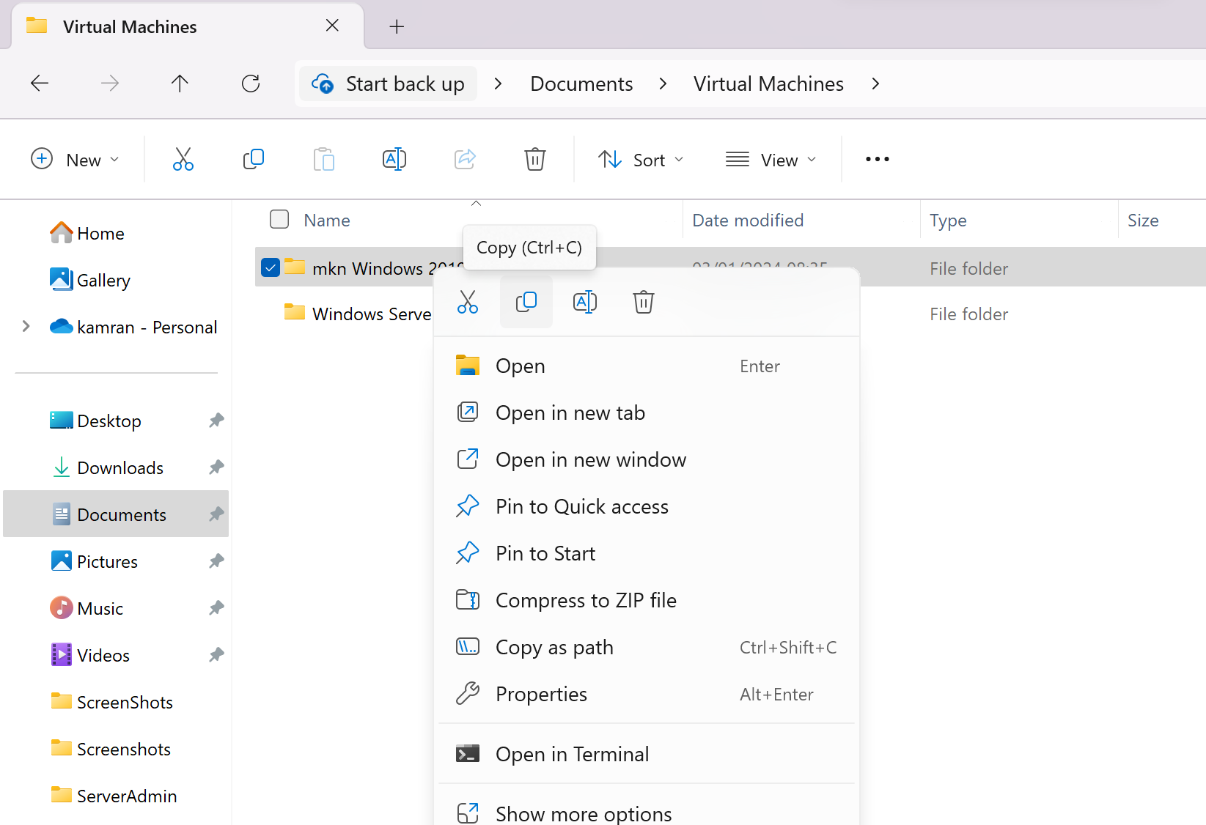
4. Right-click on it and click "Copy".
5. Go into the new folder (with your student ID) that you had just created, and right-click in it and then select "Paste". This should make a copy of your VMware Windows Server images.
6. Now if you have a suitable memory stick or an external had disk, make a copy of your server images to your external storage device in the same way.
7. This is the end of the workshop. Make sure that you have saved this Word file in a safe place and location that you know, and then upload it to the **NILE** submission folder. You can always over-write the copy in NILE with a later updated copy if necessary.
8. Also save a copy to your memory stick or use Webmail to email a copy to yourself.
9. BE 100% SURE YOU’VE RECORDED YOUR PASSWORDS SOMEWHERE FOR FUTURE WEEKS! ☺